Wireshark Lab: Getting Started v7.0

We will be using the Wireshark packet sniffer [http://www.wireshark.org/] for these labs, allowing us to display the contents of messages being sent/received from/by protocols at different levels of the protocol stack. (Technically speaking, Wireshark is a packet analyzer that uses a packet capture library in your computer).

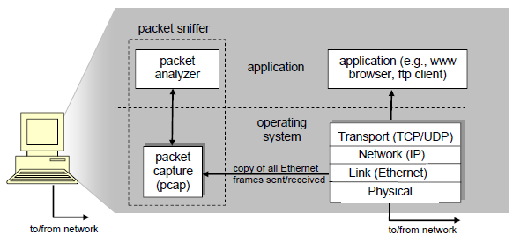
Figure 1: Packet Sniffer Structure

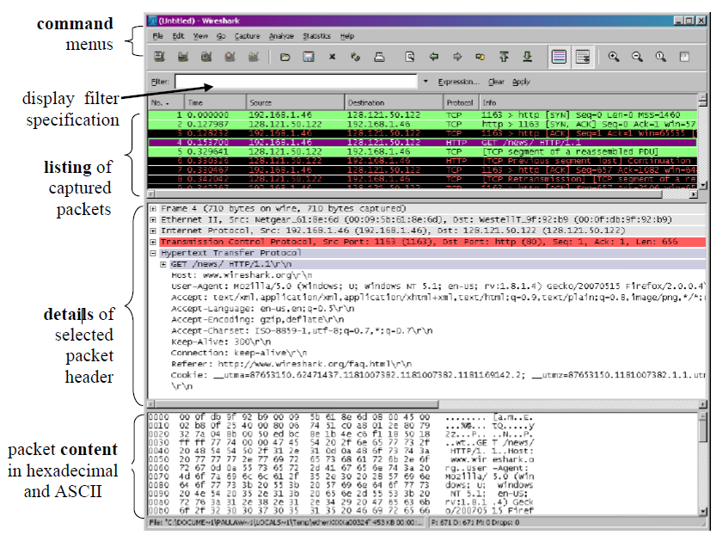
Figure 2: Wireshark Graphical User Interface, during packet capture and analysis

Taking Wireshark for a Test Run

The best way to learn about any new piece of software is to try it out!

- Start up your favourite web browser, which will display your selected homepage

- Start up the Wireshark software

- Click on Start for the interface on which you want to begin packet capture

Figure 3: Initial Wireshark Screen

- Enter the URL: http://gaia.cs.umass.edu/wireshark-labs/INTRO-wireshark-file1.html and have that page displayed in your browser

- After your browser has displayed the INTRO-wireshark-file1.html page (it is a simple one line of congratulations), stop Wireshark packet capture by selecting stop in the Wireshark capture window

- Type in “http” (without the quotes, and in lower case – all protocol names are in lower case in Wireshark) into the display filter specification window at the top of the main Wireshark window. Then select Apply (to the right of where you entered “http”). This will cause only HTTP message to be displayed in the packet-listing window.

Figure 4: Wireshark window after step 6

- Find the HTTP GET message that was sent from your computer to the gaia.cs.umass.edu HTTP server. (Look for an HTTP GET message in the “listing of captured packets” portion of the Wireshark window (see Figure 3) that shows “GET” followed by the gaia.cs.umass.edu URL that you entered

- Exit Wireshark

Congratulations! You’ve now completed the first lab.

NOTE
If you are unable to run Wireshark on a live network connection, you can download a packet trace file that was captured while following the steps above on one of the author’s Windows computers:
Download the zip file http://gaia.cs.umass.edu/wireshark-labs/wireshark-traces.zip and extract the file ip-ethereal-trace-1.
Once you have downloaded the trace, you can load it into Wireshark and view the trace using the File pull down menu, choosing Open, and then selecting the http-ethereal-trace-1 trace file.

Recall that the HTTP GET message that is sent to the gaia.cs.umass.edu web server is contained within a TCP segment, which is contained (encapsulated) in an IP datagram, which is encapsulated in an Ethernet frame

Please prepare answers to the following questions to check your understanding

The goal of this first lab was primarily to introduce you to Wireshark. The following questions will demonstrate that you’ve been able to get Wireshark up and running, and have explored some of its capabilities. Answer the following questions, based on your Wireshark experimentation:

1. List 3 different protocols that appear in the protocol column in the unfiltered packet-listing window in step 7 above.

2. How long did it take from when the HTTP GET message was sent until the HTTP OK reply was received? (By default, the value of the Time column in the packet-listing window is the amount of time, in seconds, since Wireshark tracing began. To display the Time field in time-of-day format, select the Wireshark View pull down menu, then select Time Display Format, then select Time-of-day.) locate the response frame and calculate the time difference. You can also find this information in the ‘time since request’ field in the http header.

3. What is the Internet address of the gaia.cs.umass.edu (also known as www-net.cs.umass.edu)? What is the Internet address of your computer?

4. Print the two HTTP messages (GET and OK) referred to in question 2 above. To do so, select Print from the Wireshark File command menu, and select the “Selected Packet Only” and “Print as displayed” radial buttons, and then click OK.

